Exercise: Shell scripts

1. Write a shell script to get the current date, time, username and current working directory.

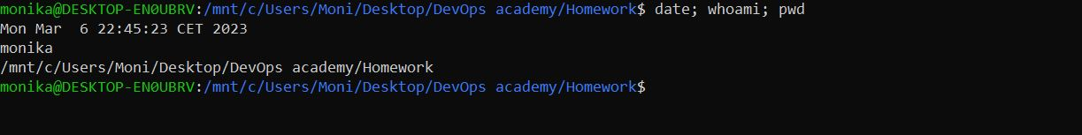

To get the time and date we can use the linux command date, same for username – whoami and for the working directory we use pwd.

1. Write a shell script that prints “I love learning about DevOps” on the screen. Message should be a variable.

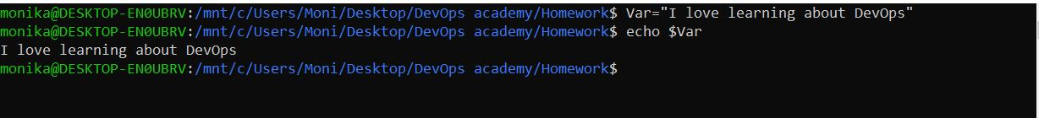

First we create the variable (value) = (key) I love learning DevOps

After we hit enter the variable is created and we can print by typing echo $Var

1. Write a shell script that displays “plan code build test release deploy” on the screen with each appearing on a separate line.

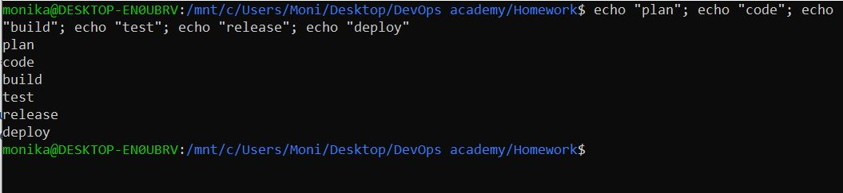

To run multiple commands at the same time we can write ; (semicolon) to declare when one command ends and another one starts.

4.Write a shell script that prompts the user for a name of a file or directory and reports if it is a regular file, a directory, or another type of file. Also perform a ls command against the file or directory with the long listing option

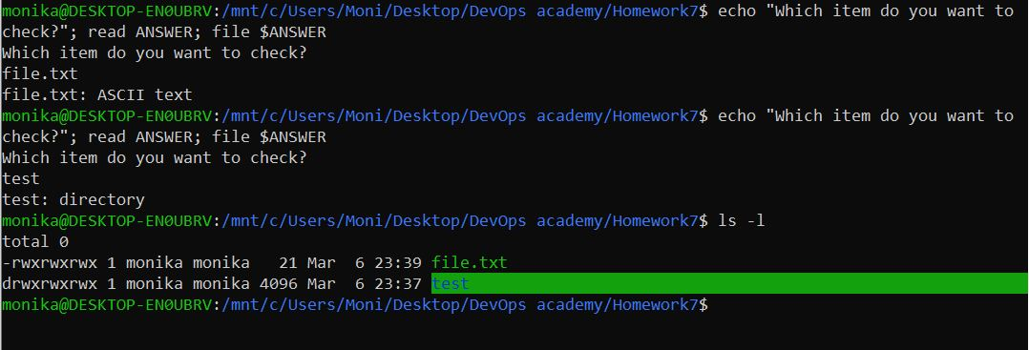

We use echo to print the question, after that we run the read command which will read the input from the user in the command line and store it a variable called ANSWER, after that we run the file command which checks what kind the item is on the previously set variable $ANSWER.  
At the end we ran the command ls – l to list long the items in the directory.

5.Use arguments in a script. Total number of arguments should be three.  
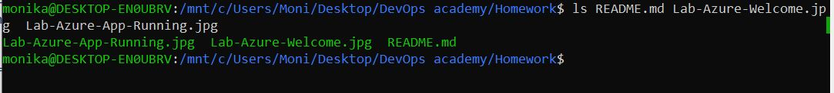

We are listing 3 arguments – Readme, Lab-Azure and Lab-Azure-App

6. Write a script that till output your name out of a variable and will display the server uptime

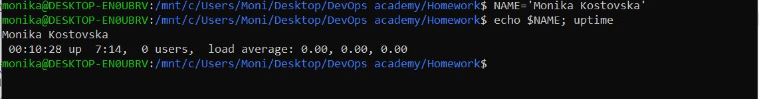

We create a variable NAME that will contain our name and after we save, we print that variable with the command uptime.